PHOTOVOLTAIC SYSTEMS
By

Student’s Name
Professor’s Name
Institutional Affiliation
Date

Photovoltaic Systems
Introduction
Renewable sources of energy are the most considered by scientists all over the world since they are pure and have no contribution to global warming. Solar energy comes out as the unique source of unlimited energy which can be used to power millions of projects across the globe. The energy provided by the sun is trapped by the photovoltaic cells in form of radiation. Solar energy is converted to electricity by the solar cells which have diverse uses ranging from domestic to industrial use. For that reason, scientists discovered that solar energy could be a source of power to meet the unlimited electricity consumption from around the globe. This called for intensive research with an aim to solve the energy crisis in the world. Therefore, the paper will focus on the short description of the usage history of photovoltaic, where it originated, how it was first used, the main milestones in the development of the photovoltaic and a concise yet informative description of the main working principle of photovoltaic.
Photovoltaic History and where it originated
The first invention of photovoltaic was made by Alexander Edmond Becquerel in 1839. The French scientist made use of two metal plates dipped in an acidic solution to demonstrate the production of an electric current after exposing the two metal plates dipped in an acidic solution to solar radiation (Mir-Artigues & del Río, 2016, 40). Later in the 1860s, a scientist known as W. Smith found out that the selenium material underwater transmitted electricity when exposed to the light source. In 1870, two American scientists William Adams and Richard Day concluded that the sun generates electricity as flow power in the selenium material.
The solar energy was in charge of the junction between the platinum and selenium, therefore, creating a photovoltaic effect. The discovery was named by Werner von Siemens ‘the scientifically of the most far-reaching importance. This also made a good number of mechanics and chemists to accept the idea of atoms. According to Mondal & Bansal (2015, 518), the selenium solar panels proved that solid material could convert light into electricity without the presence of any moving parts or heat although they failed to convert enough sunlight to provide electricity to power huge machines.
Later in 1905, Albert Einstein published his first theoretical work about photovoltaic effect well known as ‘concerning a heuristic point of view toward the emission and transformation of light’. In his work, he demonstrated fully that light has an attribute that had not been revealed there before by scientists. The main idea of his works was expanding on the fact that light is made up of packets of energy called quarta. Albert releasing his works to the members of the public gave many scientists a clear understanding of the photoelectricity. According to Mir- Artigues & del Río (2016, 42), it was discovered that the powerful photons have the ability to knock off the poorly linked electrons out of the atomic orbits. Thus, when some wires are connected to the selenium material, the liberated electrons flow through them in form of electricity.
There are four main types of PV cells (Dubey & Tay, 2013, 2). The first type of PV cells is monocrystalline silicon PV panel. The cells that make this kind of a PV cell are sliced from a cylindrical crystal of silicon enabling it to convert more than 15 percent of sun’s energy to electricity. Polycrystalline silicon PV panel is the second type of PV cells. Silicon cells are cut from an ingot of melted and recrystallize silicon and then put together in complete cells. The third type of PV cells is the thick-film silicon PV panel. Silicon is deposited in continuous process giving it a sparkling look, has a tempered glass cover and is framed in a metal module which is variant on multicrystalline technology. Amorphous silicon PV panel is the fourth type of PV cells. Silicon is placed in a thin homogenous layer therefore creating a rigid crystal structure. According to Dubey & Tay (2013, 5), amorphous silicon PV panel has an efficiency of around 6 percent.
A Cell, Module and an Array
According to Dubey & Tay (2013, 9), a PV or a solar cell refers to a semiconductor device that has the ability to convert solar energy to DC electricity through the photovoltaic effect. On the other hand, a PV module is an interconnection of individual PV cells and put in a sealed waterproof package. When modules are wired in parallel and series to come up with the desired current and voltage it is called a PV array.
Photovoltaic in Use for the First Time
In 1958 a scientist known as Gerald Pearson came up with the first silicon solar cell that was able to generate measurable electric current (Wang et al., 2015). This discovery marked the beginning of a new era fueling most of the scientists all over Europe to make attempts on how to harness the limitless energy from the sun. At that time electricity energy was in high demand due to civilization. This forced the US army to see this invention as a potential energy for the top-secret project-earth-orbiting satellites. However, when the US Navy was given the responsibility to launch the first American satellite, they opted to use the chemical batteries claiming that they could not use untried technology as a source of power for the Vanguard satellite.
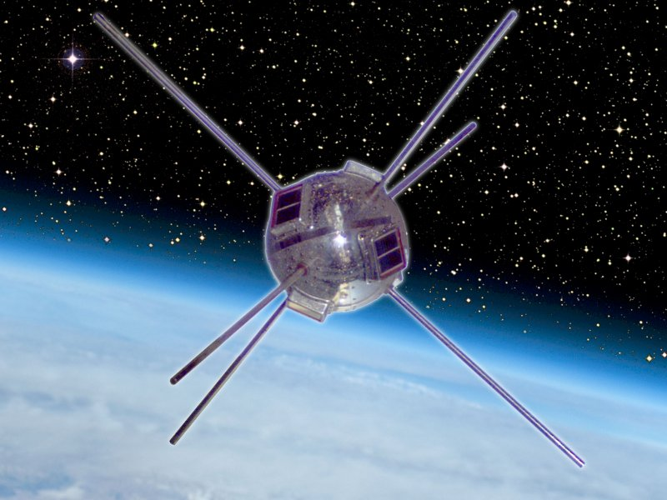
Figure 1: Vanguard I, satellite orbits the earth using PV cells (2017).
The step of the US Navy to use the chemical batteries was highly opposed by late Dr. Hans Ziegler who claimed that the chemical batteries would run out of power in days forcing the electronic equipment which was worth millions of dollars to silence (Wang et al., 2015). What Dr. Hans tried to insist on is that the solar cells would power the electronic equipment for years and hence they were supposed to be used. No matter how he tried to change the minds of the US Navy, they remained unmoved and instead used a dual power system of silicon solar cells and chemical batteries. Just as what Dr. Hans had claimed the chemical batteries shut after a few days but the silicon solar cells supported the Vanguard satellite for years.
The use of photovoltaic cells flourished in the 1960s and 1970s in remote areas since the cost of the solar cells was not a factor to be considered anymore. According to Wang et al. (2015), what different manufacturers worried about is durability, efficiency and size of the solar cells.
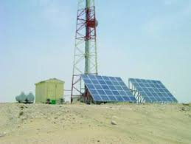
Figure 2: PV cell in remote area (2017).
Major Milestones in the Development of Photovoltaic
The first milestone was made by a French scientist known as Edmond Becquerel in 1839. He discovered a photovoltaic effect during an experiment with an electrolytic cell made of metal electrodes dipped in an electric conducting solution. Edmond realized that the amount of electricity increased when the solution was directed to sunlight. On the other hand, a mathematician known as August Mouchet came up with the idea of solar-powered steam engines and after two decades, his assistant invented the first solar-powered engine which since then attracted a variety of applications (Hoang, 2017). Later in 1873, Willoughby discovered the photoconductivity of selenium.
In 1876, both Richard Evans Day and William Grylls Adams came to find that selenium produces electricity when exposed to solar energy. After a period of 4 years, in 1880 Samuel P. Langley invented a bolometer to measure light from the sun’s heat rays and the faintest stars. Also, Charles Fritts in 1883 invented the first solar cells that were made from selenium wafers (Ju et al., 2017, 307). Invention continued in 1887 when Heinrich Hertz came to realize that ultraviolet rays had the capability to interfere with the lowest level of voltage that would cause a spark.
In the mid-1970s power was very costly in the rural areas and this propagated to transport the PV cells to complement the grid electricity and the fuel generators that were not competent. According to Hoang (2017), silicon was discovered in 1976 which became a cheap and an alternate material for PV component. After this invention, PV cells were widely used on the oil rigs for lighting purposes before the declaration of the illegal use of batteries in offshores.
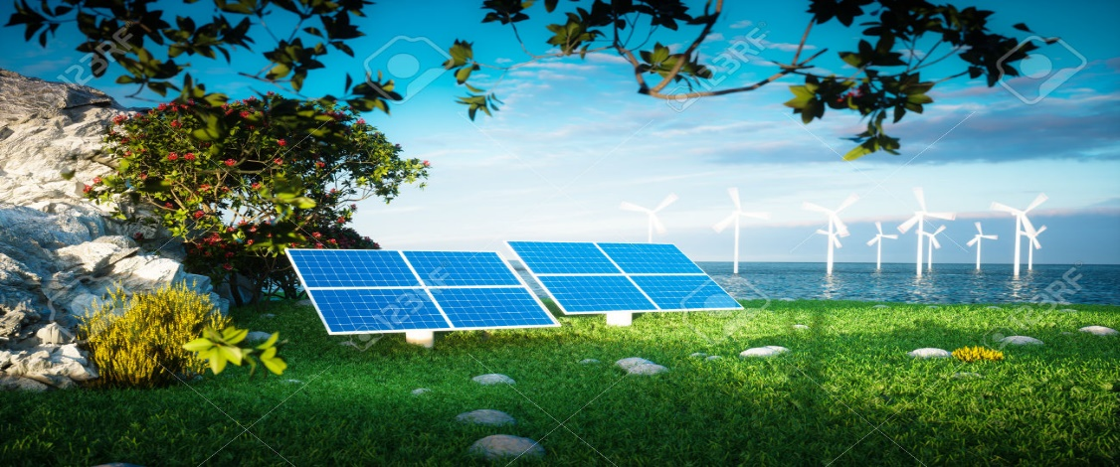
Figure 3: PV photovoltaic on offshore (2017).
The high cost of electricity in the rural areas forced the manufacturers to start substituting the silicon material with gallium arsenide, copper sulfide and cadmium. An engineer in the 1980s invented a screen printing PV cells by mixing glass with adhesive silver (Ju et al., 2017, 310). On the other hand, monitoring the movement of wild animals was easily undertaken by use of mini PVs to power radio transmitters for research purposes. Later in the early 1990s, PVs were manufactured in flexible plastic sheets. This made it be widely used, for example, in the supply of energy to emergency phone booths in most of the highways in the United States.
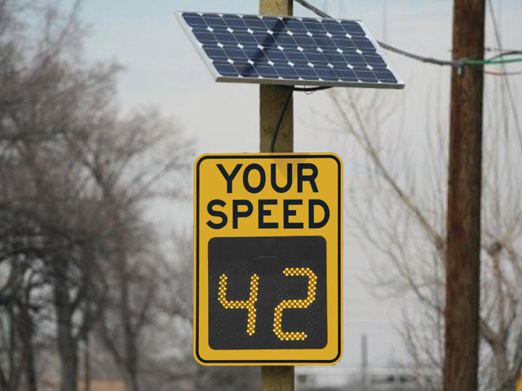
Figure 4: Highway road sign powered by photovoltaic cells (2017).
Currently, there is widespread use of photovoltaic cells in homes as a source of electricity to complement power when there are blackouts. Solar power has also been used in remote controlled electric cars and aircrafts (Hoang, 2017). On the other hand, manufacturers have come up with new super thin PVs that are up to 3000 times more efficient compared to the first selenium cells.
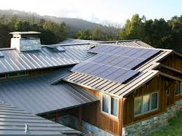
Figure 5: Photovoltaic cells in homes on rooftops (2017).
According to Ju et al. (2017, 313), the federal government also utilized the photovoltaic technology as it built some power plants of photovoltaic. The plants were to generate electricity to many parts of the country such as California. Since the photovoltaic plants covered a huge area, they were named as solar farms by the government of the United States.

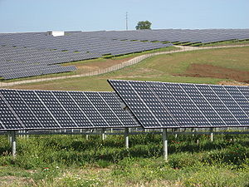
Figure 6: A photovoltaic power station (2017).
Main Working Principle of Photovoltaic
The solar cells work under the principle of junction effect principle. To have a clear understanding of this principle, it is good to have adequate knowledge about p-type and n-type materials. According to Gonzalez-Pedro et al. (2014, 889), the p-type or the n-type materials are obtained using the doping process. What doping process simply means is that another atom has to be inserted in a bulk crystal. For example, considering the silicon crystal, each silicon atom usually has four electrons in the valence band. The electrons in the valence band tend to form a bond with other silicon atoms. The structure is referred to as a crystal because the silicon atoms are perfectly aligned. Therefore, it is easy to convert the structure into a p-type or an n-type through doping.
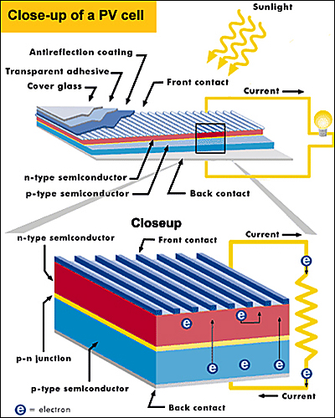
Figure 7: The typical structure of the PV cells (2017).
One of the elements that can be used to complete the doping process with silicon is boron. In boron valence band, there are 3 electrons. According to Lee et al. (2014, 8749), if boron is inserted into the crystal instead of silicon, it is obvious that one electron will be missing since boron has 3 electrons. The missing bond coming from the missing electron is referred to as a ‘hole’ which is positively charged. In other words, the material is now known as a p-type material.
The doping process can also utilize phosphorous instead of boron. Phosphorous has 5 atoms in its valence band. When phosphorous is inserted into the lattice, 4 electrons of phosphorous will be able to form bond leaving the 5th electron hanging (Gonzalez-Pedro et al., 2014, 890). The 5th electron is nearly free hence it will be very close to the conduction band making it have the potential to leave the phosphorous because it has small thermal energy. First, the new material formed is called an n-type since there is an extra electron in the structure. Second, it is called an n-type electron because it has the potential to give away the electrons unlike the p-type.
Bringing together the n-type which is ready to give away electrons and p-type which is ready to receive electron ends up creating a p-n junction through diffusion (Lee et al., 2014, 8751). The holes diffuse from p-type to n-type and the electrons start to diffuse from n-type to p-type region. After a short while at the interface region, the electron-hole free region is created which is commonly known as the depletion region. An electric field poses a force to the electron entering the depletion region since all the electrons are negatively charged.
According to Gonzalez-Pedro et al. (2014, 892), any electron that is generated from the sunlight may easily pass the n-side of the junction. Hence, a wire connecting the p-type to the n-type will enable the electron flow from the p-type. However, current needs to be created using an external energy to energize the electrons in the p-type to cross to the depletion region thus making the solar energy to be the most appropriate energy source.
Conclusion
Having discussed the history of photovoltaic, where it originated, how it was first used, the main milestones in the development and the main working principle of photovoltaic, it makes it be the most sustainable/renewable energy source. It is evident that photovoltaic is the most appropriate source of energy to meet the world unlimited power needs. Although research is still undergoing on how to make the photovoltaic be the most dependable energy source, up to now it has proved to be the best coming from impacts it has on the human activities across the globe. The PV technology still has more potential to develop and reach far heights than what has taken place in the past 200 years. Sincerely speaking photovoltaic remains the cleanest source of energy to combat the effect of global warming that is currently facing the whole world. Governments need to invest heavily in this technology by formulating some policies that encourage the use of photovoltaic energy source which will enhance the overall world energy security.

References
Dubey, S. and Tay, A.A., 2013. Testing of two different types of photovoltaic–thermal (PVT) modules with heat flow pattern under tropical climatic conditions. Energy for Sustainable Development, 17(1), pp.1-12. (http://sci-hub.cc/10.1016/j.esd.2012.09.001)
Gonzalez-Pedro, V., Juarez-Perez, E. J., Arsyad, W. S., Barea, E. M., Fabregat-Santiago, F., Mora-Sero, I., & Bisquert, J. (2014). General working principles of CH3NH3PbX3 perovskite solar cells. Nano letters, 14(2), 888-893.(http://sci-hub.cc/10.1021/nl404252e)

Hoang, S., 2017. The environmental history of solar photovoltaic cells. (https://repository.wellesley.edu/cgi/viewcontent.cgi?referer=https://scholar.google.com/&httpsredir=1&article=1019&context=library_awards)

Image for highway road sign power by photovoltaic cells. (2017). Retrieved from https://www.google.com/url?sa=i&rct=j&q=&esrc=s&source=images&cd=&cad=rja&uact=8&ved=0ahUKEwiZtMH_o4zXAhXJWRQKHRDTDwkQjRwIBw&url=https:%2F%2Fen.wikipedia.org%2Fwiki%2FRadar_speed_sign&psig=AOvVaw3NmTIJsYN4G2yfuZk3vdwp&ust=1509038304386403 on 25th October 2017.
Image for photovoltaic cells in homes on rooftops. (2017). Retrieved from https://www.google.com/url?sa=i&rct=j&q=&esrc=s&source=images&cd=&cad=rja&uact=8&ved=0ahUKEwjztPq6o4zXAhWI7BQKHThyCgMQjRwIBw&url=http:%2F%2Fwww.hgtv.com%2Fremodel%2Fmechanical-systems%2Fsolar-shingles-get-solar-power-without-changing-your-roof-line&psig=AOvVaw16sZrLaEJf7wlCQYq4yWew&ust=1509038163105386 on 25th October 2017.
Image for PV cell in the remote area. (2017). Retrieved from https://www.google.com/url?sa=i&rct=j&q=&esrc=s&source=images&cd=&cad=rja&uact=8&ved=0ahUKEwiYnbXgqIzXAhVK1oMKHfuGBxsQjRwIBw&url=https:%2F%2Fwww.solarserver.com%2Fknowledge%2Fbasic-knowledge%2Fstand-alone-photovoltaic-systems.html&psig=AOvVaw0SM5O1KRvL81zn1uh7EsT9&ust=1509039545662167 on 25th October 2017.
Image for PV photovoltaic on offshore. (2017). Retrieved from https://www.google.com/url?sa=i&rct=j&q=&esrc=s&source=images&cd=&cad=rja&uact=8&ved=0ahUKEwjvt-Pqp4zXAhUj6oMKHd_rBBoQjRwIBw&url=https:%2F%2Fwww.123rf.com%2Fphoto_84608966_renewable-energy-concept--photovoltaic-and-offshore-wind-turbines-3d-rendering.html&psig=AOvVaw2C8nYCSrhP2sH5TxMhTPmc&ust=1509039324081138 on 25th October 2017.

Image for typical structure of the PV cells. (2017). Retrieved from https://www.google.com/url?sa=i&rct=j&q=&esrc=s&source=images&cd=&cad=rja&uact=8&ved=0ahUKEwixiuCgoYzXAhUKaRQKHXCyC-0QjRwIBw&url=http:%2F%2Fsolarcellcentral.com%2Fsolar_page.html&psig=AOvVaw3CAvjkSZ79lyUmQwrpqJOi&ust=1509037556853569 on 25th October 2017.
Image for Vanguard I, satellite orbits the earth using PV cells. (2017). Retrieved from https://www.google.com/url?sa=i&rct=j&q=&esrc=s&source=images&cd=&cad=rja&uact=8&ved=0ahUKEwi_2ImxqYzXAhWHtxQKHeOSAKkQjRwIBw&url=https:%2F%2Fen.wikipedia.org%2Fwiki%2FVanguard_1&psig=AOvVaw25KQbkQfR5f6FV2HI-Mr9F&ust=1509039768926527 on 25th October.
Ju, X., Xu, C., Hu, Y., Han, X., Wei, G. and Du, X., 2017. A review on the development of photovoltaic/concentrated solar power (PV-CSP) hybrid systems. Solar Energy Materials and Solar Cells, 161, pp.305-327. (http://sci-hub.cc/10.1016/j.solmat.2016.12.004)
Lee, C.H., Kim, D.R. and Zheng, X., 2014. Transfer printing methods for flexible thin film solar cells: basic concepts and working principles. Acs Nano, 8(9), pp.8746-8756. (http://sci-hub.cc/10.1021/nn5037587)
Mir-Artigues, P. and del Río, P., 2016. Short history and recent facts of photovoltaic generation. In The Economics and Policy of Solar Photovoltaic Generation (pp. 37-69). Springer International Publishing. (http://libgen.io/book/index.php?md5=638E44FCACD4C24A4BC6FB14495DBF75)
Mondal, A.K. and Bansal, K., 2015. A brief history and future aspects in automatic cleaning systems for solar photovoltaic panels. Advanced Robotics, 29(8), pp.515-524. (http://sci-hub.cc/10.1080/01691864.2014.996602)
Photovoltaic power station. (2017). Retrieved from https://en.wikipedia.org/wiki/File:SolarPowerPlantSerpa.jpg on 25th October 2017.
Wang, X., He, L. and Ju, C., 2015. Application of photovoltaic power generation system in military systems. (http://sci-hub.cc/http://www.atlantis-press.com/proceedings/icmse-15/25845546)

